Steps to Create a GitHub Issue in Tipitaka-xml Repo.

Step #1 : Ensure you have a GitHub Account. (Its free for this requirement).
If you already have a GitHub Account, then please Skip the Step #1, and proceed to Step #2
Open the Site : https://github.com/
If you do not have a “GitHub” Account, then click on Sign Up, else “Sign-In”
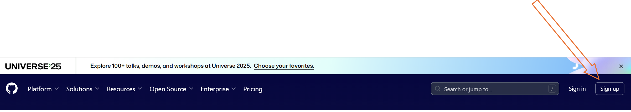

If you have a Google/Gmail Account, then you can “Continue with Google”, or create a new account using email/password.
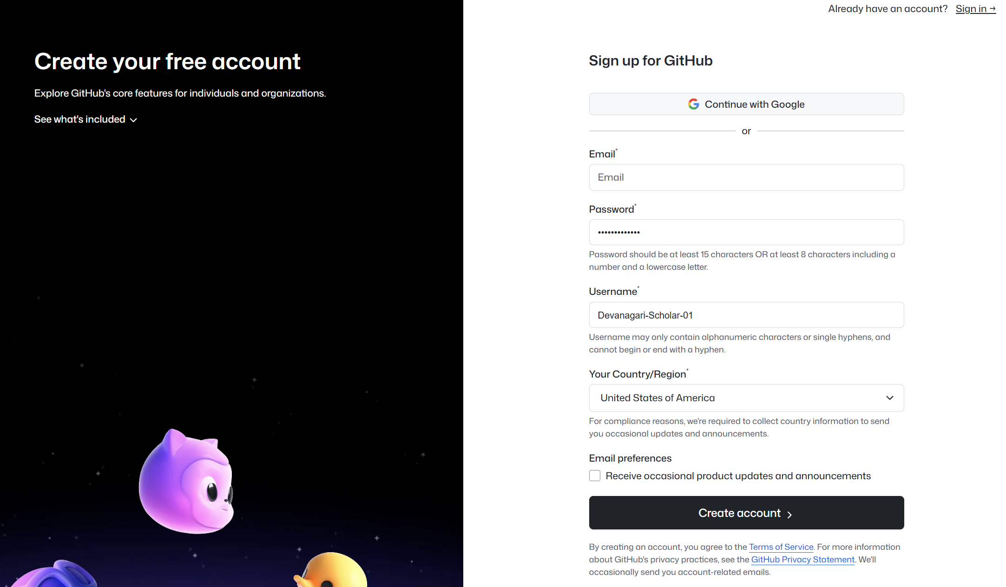

If you decide to use Google account, then allow access to Name/Email, and Continue.


Click Create account
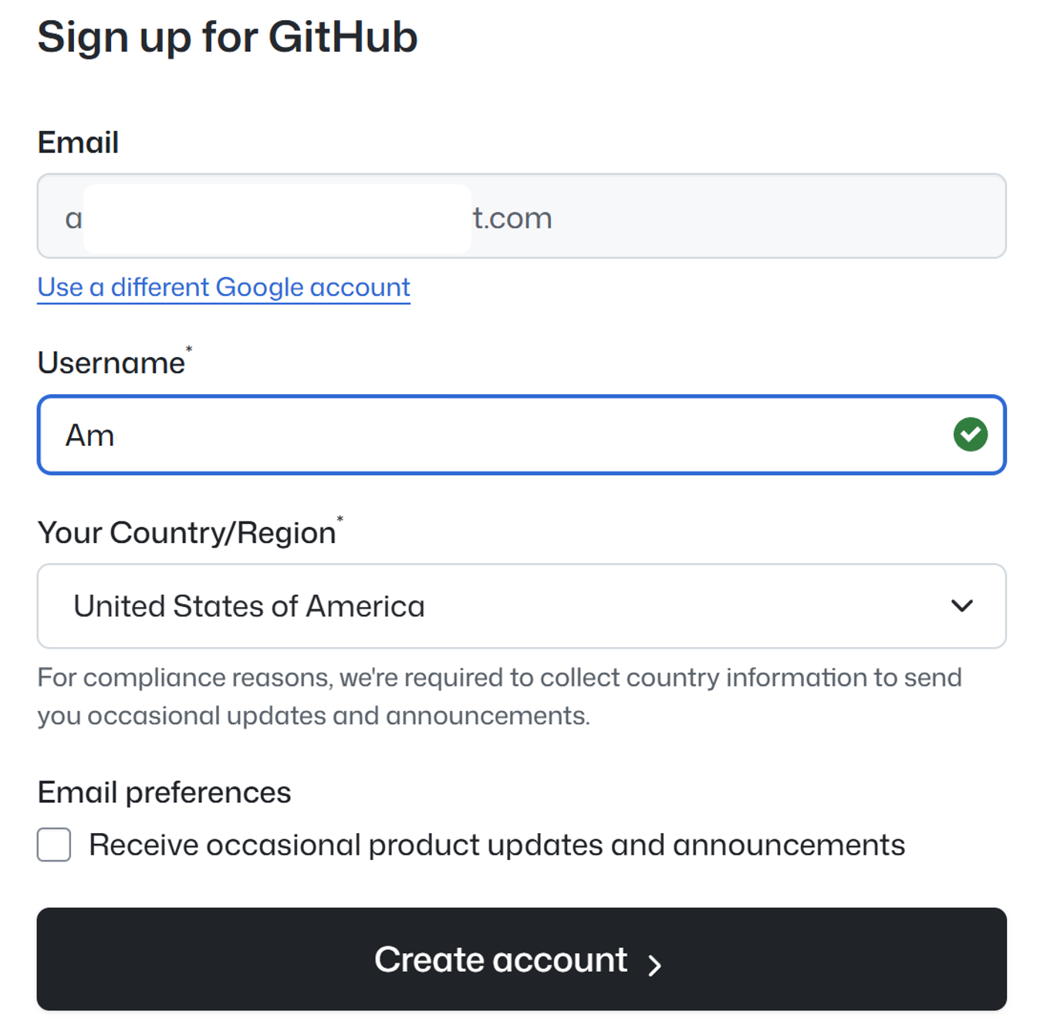

Once you Login to GitHub for first time, you should see a screen like this.
Check the Right Side, you would see your GitHub User-Name. Make a note of the same for future.

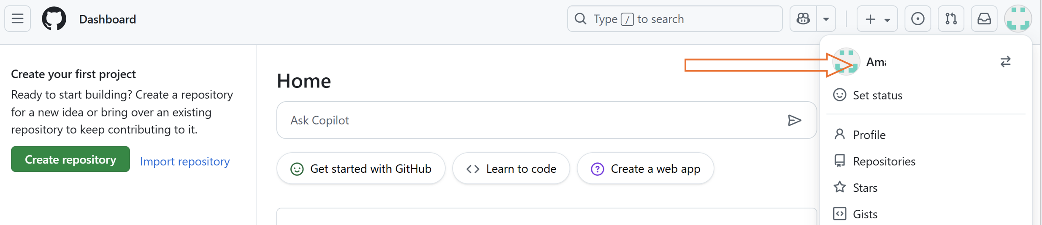

Step-2 : Create the Issue in GitHub Repo

Open the GitHub Repo, Navigate to Issues Tab : https://github.com/VipassanaTech/tipitaka-xml/issues

You should see a list of open issues in the Repository. Click on “New Issue” to create a new Issue.
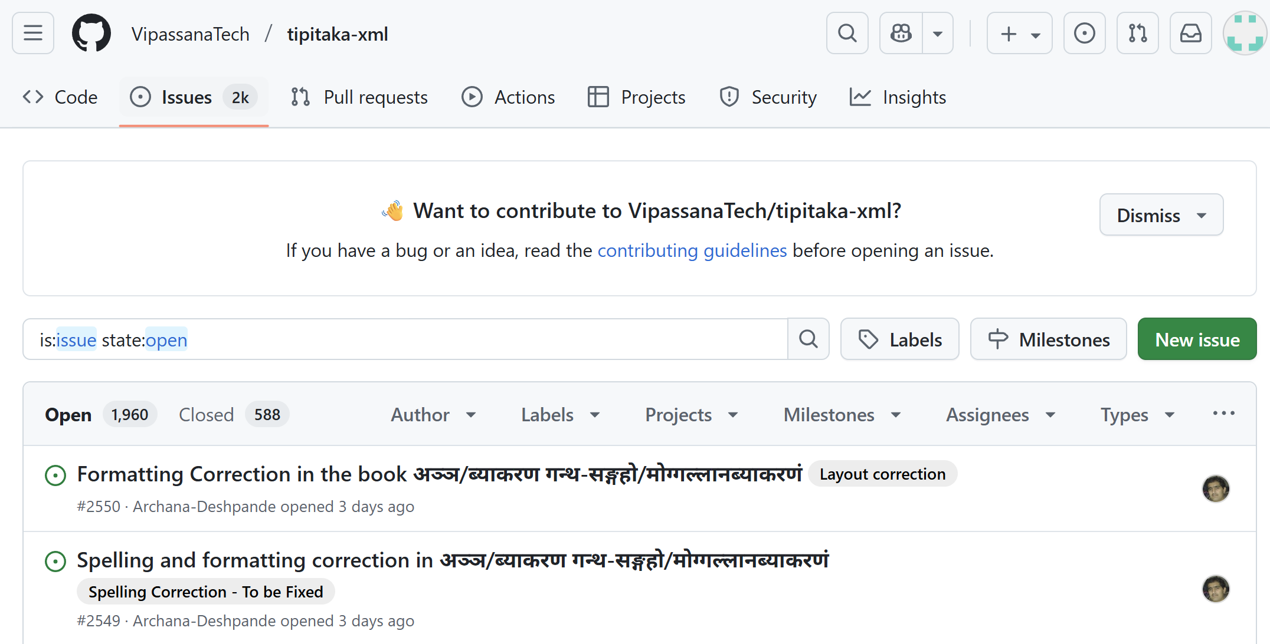

Provide a clear Title, and as much details as you can in the description.
If required you can paste a Screen shot (E.g. on Windows “Print-Screen” => “Ctrl-V” )

The Issue may appear like this
The Left side shows the Screenshot (Optional, If needed).
The Right Side shows the Issue Title and Description. Please provide as much description as possible to pinpoint the specifics.
(No need to Select the Assignees, Labels, etc. ). Click on “Create”.
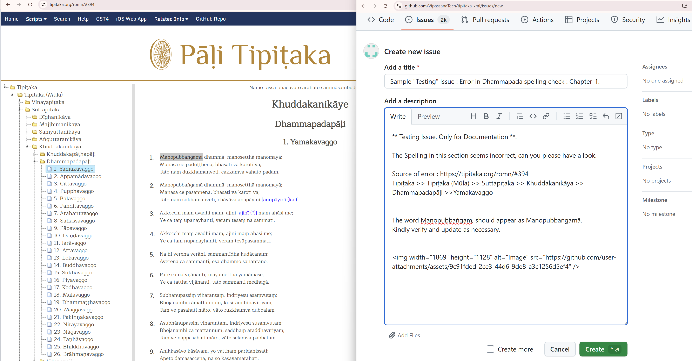

Once you Create the Issue, It will appear as below. With a unique issue #id. (e.g. #2551 here).

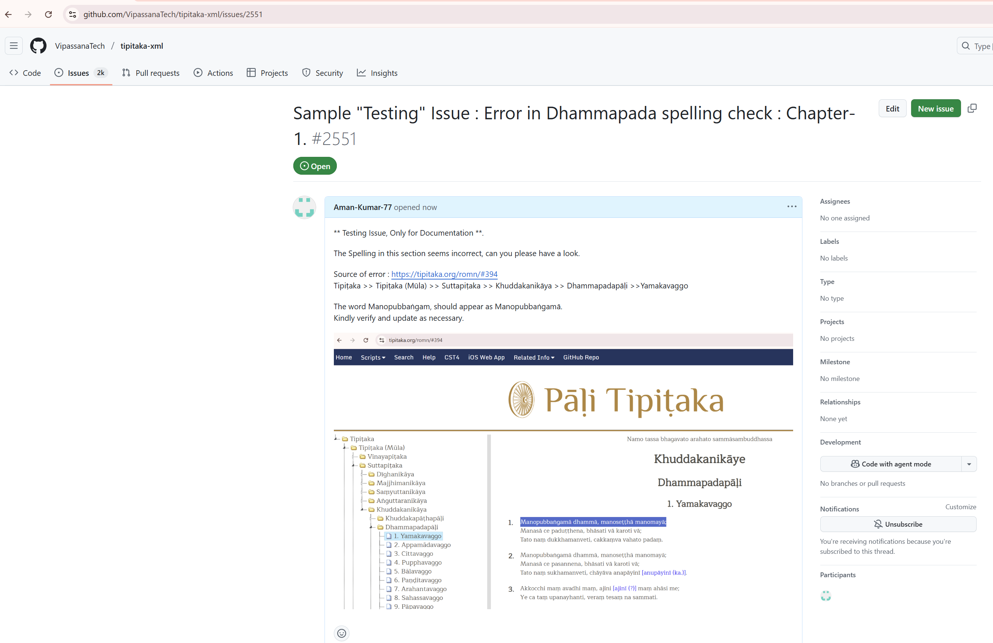

That’s it. The Tipitaka team will have a look at the issue and update it.
You can please check back the issue by searching the issue ID, or the Title text.

Thank you.

